PERFORMING THE ALTER, UPDATE AND DELETE IN VIEW

1. View table successfully created in sum(sales) and min(sales)

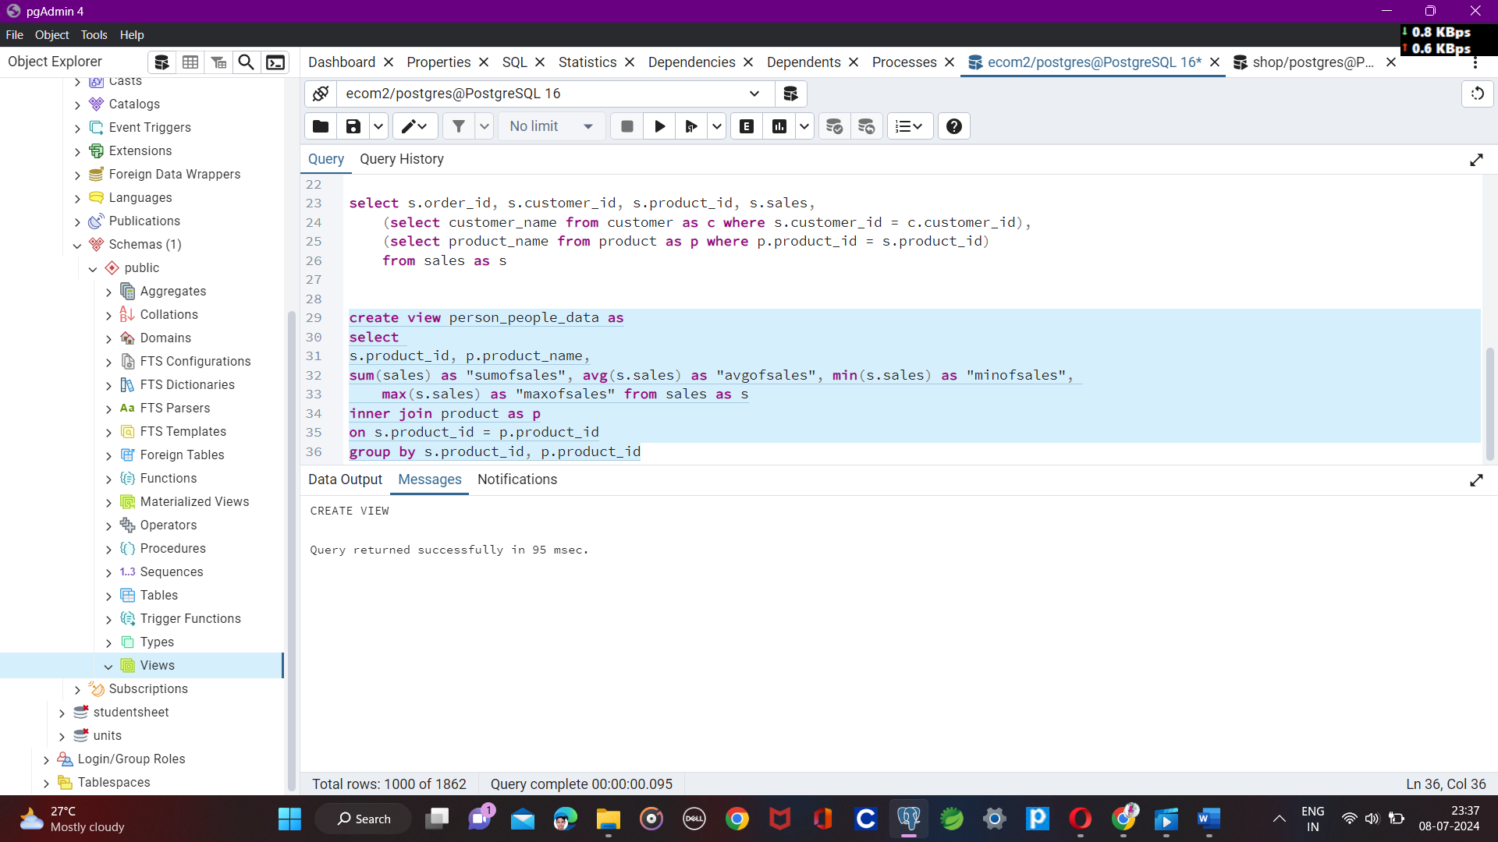

1. Error when using the adding a column

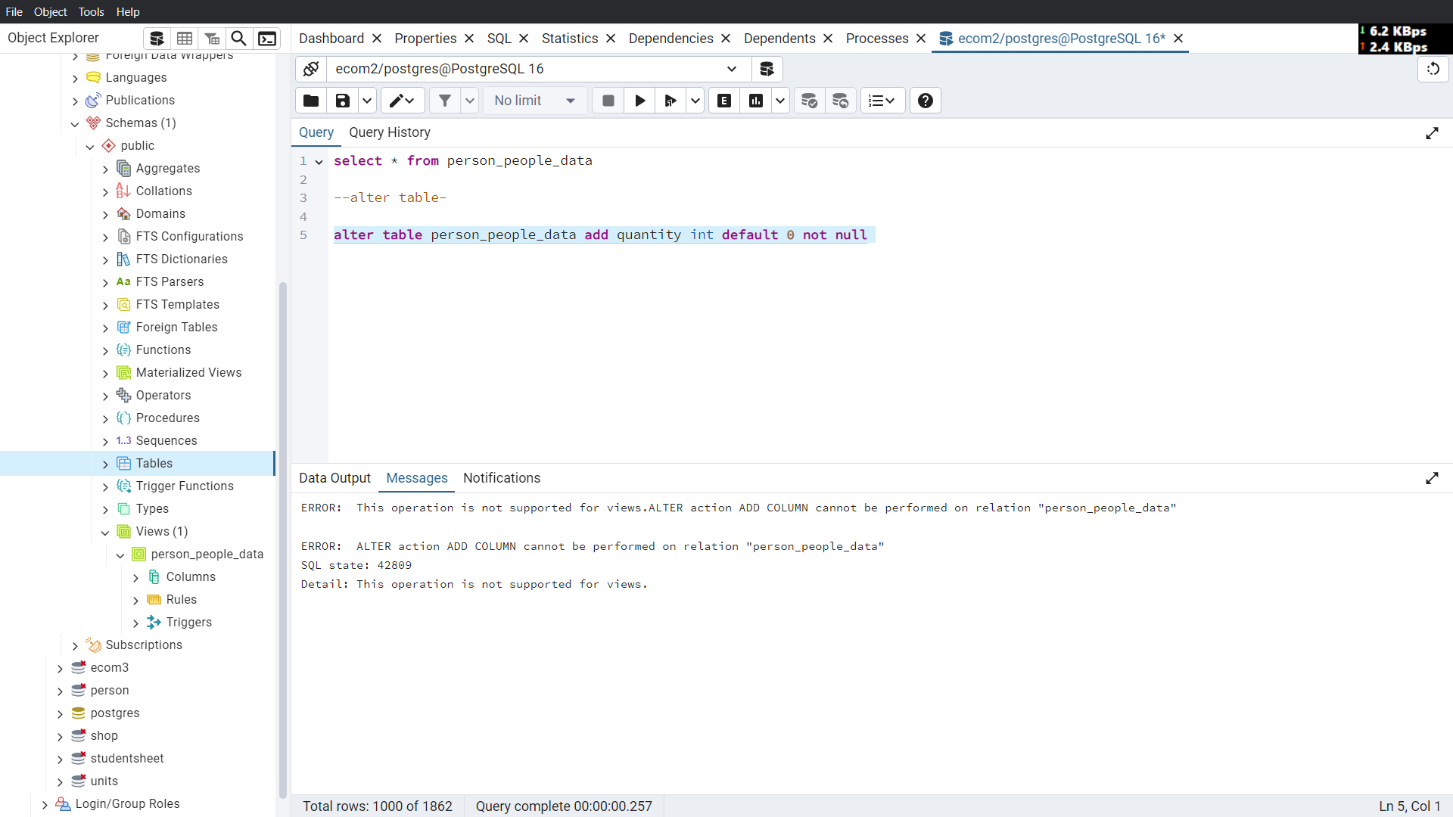

1. Successfully run the rename syntax

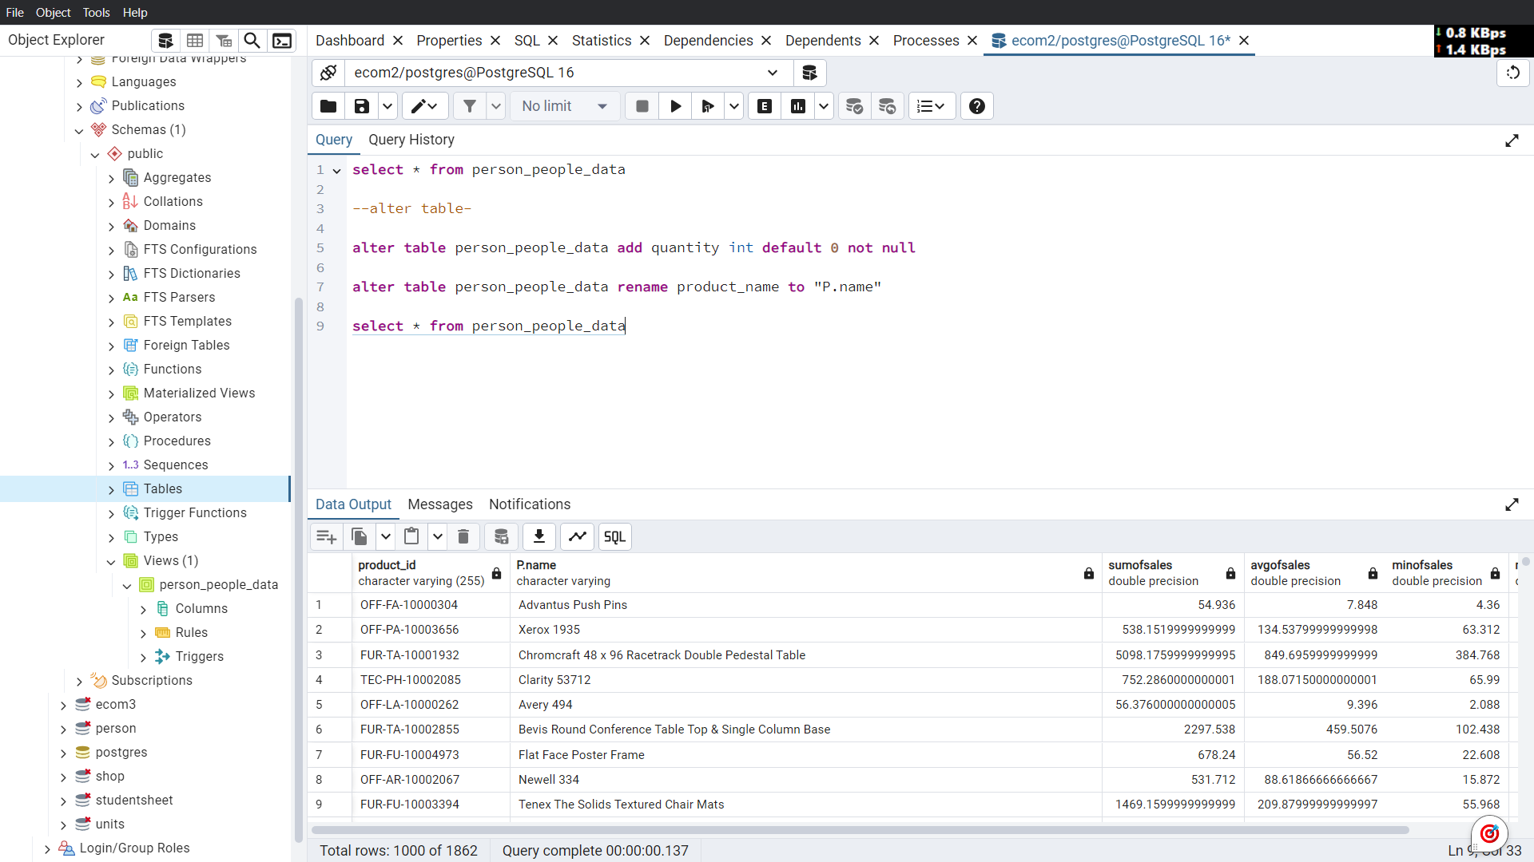

1. Update is not performing in view

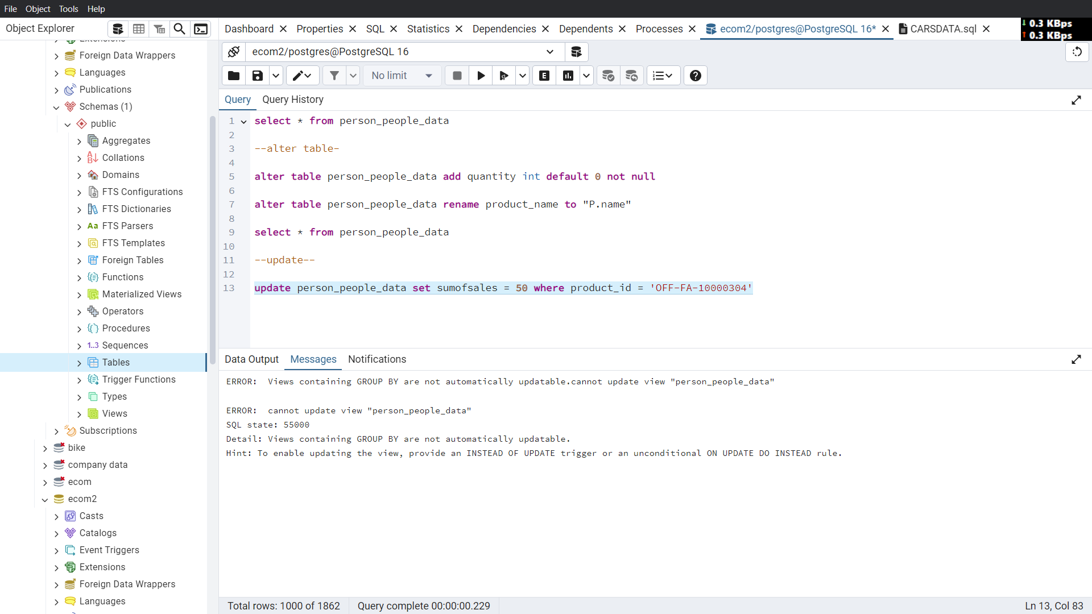

1. Delete is not performing in view

